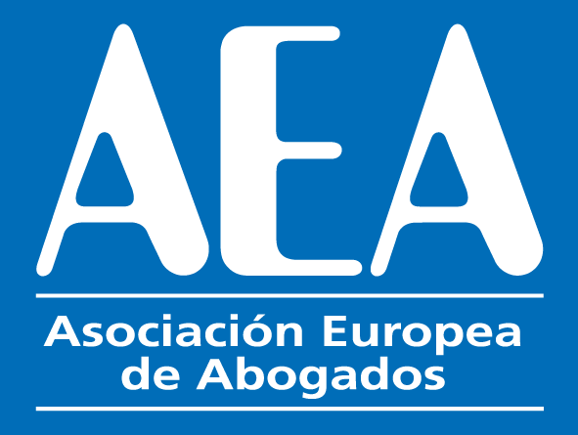
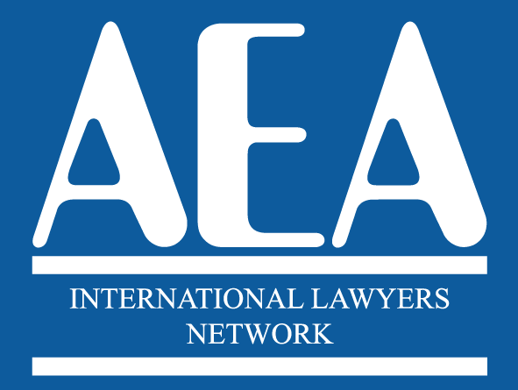

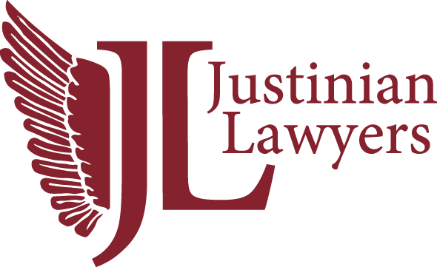

XVI INTERNATIONAL CONGRESS

Barcelona

26th and 27th May 2022

BOOKING FORM FOR MEETING PACKAGE

HOTEL HESPERIA HYATT BARCELONA
Gran Via,144 / 08907 L´Hospitalet de Llobregat (Barcelona) Spain
T: +34 93 413 50 45

The present form has to be sent duly filled as per acceptance directly to
to europea1@aeuropea.com

*****************************************************************************

Surname: __________________________________ First Name: _____________________________
Country: ________________________
E-mail: _________________________________________________
Phone:__________________________________________________

MEETING PACKAGE

26th May and 27th May – Meeting Participation Fee 300 euros per person

Number of people

(Includes the dinner of 26th May, the lunch of 27th May, the dinner of 27th May and two Coffee-Breaks the 27th May and the proportional amount for the booking of the Auditorium and Audiovisuals.)

GUESTS

DINNER ON THE 26TH MAY. Supplement for guests that don´t take the meeting package and attend the dinner on the 26th May:
71,50 € per person – Number of people:

DINNER ON THE 27TH MAY. Supplement for guests that don´t take the meeting package and attend the dinner on the 27th May
71,50 € per person – Number of people:

PAYMENT CAN BE MADE BY CREDIT CARD IN https://www.aeuropea.com/payment-by-credit-card-or-payp OR BY BANK TRANSFER TO THE FOLLOWING ACCOUNT
NAME OF BENEFICIARY: . ASOCIACIÓN EUROPEA DE ABOGADOS

BANK NAME AND ADDRESS: C/ Gral. O'Donnell, 11, 03003 Alacant, Alicante
IBAN CODE: . ES69 0182 0101 76 0201534148

BANK BIC CODE BBVAESMMCCC

BENEFICIARY’S BANK ACCOUNT NUMBER: 0182 0101 74 0201569559

