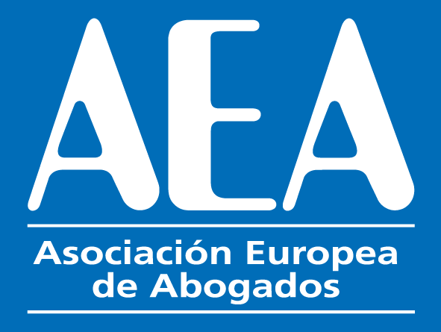
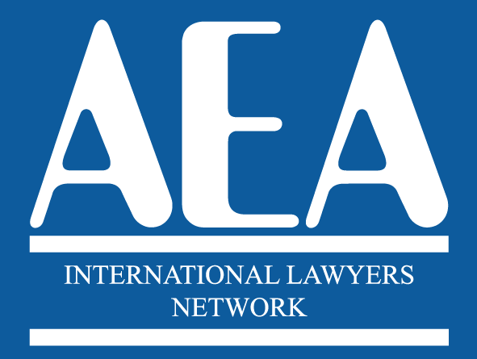

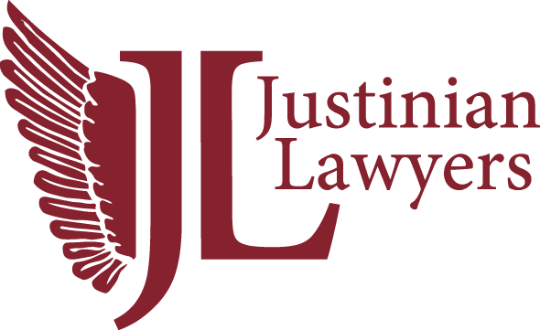

XVI INTERNATIONAL CONGRESS
Barcelona
26th and 27th May 2022

ATTENDEES LIST
- AFGHANISTAN | KHALID MASSOUDI  Masnad Law Firm | khalid.massoudi@gmail.com
- ALGERIA | AMINE GHELLAL  Ghellal & Mekerba | amine.ghellal@ghellal.com
- ALGERIA | YASMINE HIDOUK  Ghellal & Mekerba | amine.ghellal@ghellal.com
- ALGERIA | IGUENANE FAOUZI  Cabinet d'avocats et de coneiller juridique | iguenanavocat@gmail.com
- ALGERIA | LINDA YAMINA ETTOUAHRIA | linda.ettouahria@perrimond.eu
- ALGERIA | ABDALLAH HAMDANI  Hamdani Abdallah | hamdaniabdallah84@gmail.com
- ARGENTINA | PABLO NICASTRO  Barreiro, Oliva, De Luca, Jaca & Nicastro | goliva@bodlegal.com
- ARGENTINA | VICTORIA CASALE  Barreiro, Oliva, De Luca, Jaca & Nicastro | goliva@bodlegal.com
- BELGIUM | KAREL MUL  Mul Law Offices | info@drmul.com
- BELGIUM | BRIGITTE MUL-VAN den BOSSCHE  Mul Law Offices | info@drmul.com
- BELGIUM | ANNELIES HEIRMAN  Flex Advocaten Vof | info@flexadvocaten.be
- BELGIUM | ALEXANDER WYNTER  Flex Advocaten Vof | info@flexadvocaten.be
- BELGIUM | MICHAEL SCHREVENS  Advocatenkantoor Schrevens & Michiels | info@schrevens-michiels-law.be
- BELGIUM | NADIA MICHIELS  Advocatenkantoor Schrevens & Michiels | info@schrevens-michiels-law.be
- BRAZIL | NEIL MONTGOMERY  Montgomery & Associados - Montgomery Sociedade de Advogados | neil.montgomery@montgomery.adv.br
- CAMEROON | BAH QUINTALINE LUM  Fondong and Partners | fondong@fondongandpartners.com
- CAMEROON | ERNEST AWUNGJIA  Fondong and Partners | fondong@fondongandpartners.com
- CAMEROON | GILBERT A. GONGAM  Bongam & Youmbi Law Firm | info@bongam-youmbilawfirm.com
- CAMEROON | LEKEAKA COLUMBUS NKEMAKOH  Fondong and Partners | fondong@fondongandpartners.com
- CHINA | PETER PANG  IPO Pang Xingpu Law Firm | ppang@ipopang.com
- COLOMBIA | HELENA CAMARGO POSSE  Posse Herrea Ruiz | phr@phrlegal.com
- COSTA RICA | ALBERTO PAULY  GHP Abogados | apauly@ghp.cr
- COSTA RICA | ZOILA ROSA VOLIO  GHP Abogados | apauly@ghp.cr
- CYPRUS | CHRISTIANA MILIS  Christiana Petrou Milis LLC | Christiana.milis@blackmills.com
- CYPRUS | MRS. MAVROKORDATOS  Christiana Petrou Milis LLC | Christiana.milis@blackmills.com
- CZECH REPUBLIC | ZDENKA NOCAROVÁ  Nocarová Partners Advokáti s.r.o | znocarova@nocarova-law.com
- CZECH REPUBLIC | ALEXANDER BELOHLAVEK  Alexander J. Bělohlávek | a.belohlavek@ablegal.cz
- CZECH REPUBLIC | TEREZA PROFELDOV  Alexander J. Bělohlávek | a.belohlavek@ablegal.cz
- CZECH REPUBLIC | JAN SAMLOT  Alexander J. Bělohlávek | a.belohlavek@ablegal.cz
- DENMARK | MAX KRASNIK  Krasnik & Partnere Advokater | advokater@krasnik.dk
- EGYPT | YASER GAMALUDDIN HAMAM  The Egyptian Law Firm | info@egypt-law.com
- EQUATORIAL GUINEA | INOCENCIO MEMBILA MBULA  Bufete Membila Mbula & Abogados S.L. | defender.abogados.ge@gmail.com
- ETHIOPIA | DAGNACHEW TESFAYE ABETEW  Dagnachew & Mahlet Law Office (DMLO) | dagnachew@dmethiolawyers.com
- FRANCE | MARIE –CLAIRE FREUNDLICH  Freundlich Lawyer office | freundlichmc@gmail.com
- FRANCE | CONSTANTIN KARAGOUNIS  Karagounis & Partners | constantin.karagounis@karagounislawfirm.com
- FRANCE | LYDIA KARAGOUNIS  Karagounis & Partners | constantin.karagounis@karagounislawfirm.com
- FRANCE | VASSILKA CLIQUET  Cabinet Cliquet | contact@cabinet-cliquet.eu
- FRANCE | JOSÉPHINE PIC  Cabinet Cliquet | contact@cabinet-cliquet.eu
- FRANCE | ZELMA MICHEL | zelmamichel@gmail.com
- GABON | REGINE d’ALMEIDA MENSAH  Cabinet aître d'Almeida | regine_dalmeida@yahoo.fr
- GERMANY | STEFFEN KOSTER  Kanzlei Königstraße Köster & Kollegen Rechtsanwälte Fachanwälte Steuerberater | s.koester@kanzlei-koenigstrasse.de
- GERMANY | SILVIA C. GROOPLER  Advocatae Groppler Silbermann Partnerschaftsgesellschaft – Rechtsanwältinnen | info@advocatae.de
- GERMANY | ULRIKE SILBERMANN  Advocatae Groppler Silbermann Partnerschaftsgesellschaft – Rechtsanwältinnen | info@advocatae.de
- GREECE | LAURA CONVERTINI  Convertini Law Services | laura@convertinilawservices.com
- GREECE | YIANNIS PANTELIDIS  PD Law Offices | y.pantelidis@pdlawoffices.gr
- GUATEMALA | JUAN JOSE PORRÉS  Legantis Law | juan.porres@legantislaw.com
- GUATEMALA | TERESITA DE JESÚS MÉRIDA  Legantis Law | juan.porres@legantislaw.com
- INDIA | SAMEER RASTOGI  India Juris | bengaluru@indiajuris.com
- INDONESIA | CHAMELIA SARI  Prawiranegara Intellectual Property | info@prawiranegara.co.id
- IRAQ | AYMEN MAHDI  Aymen Mahdi Aljuboori | info@ajc.iq
- ISRAEL | LOUIS GARB  Louis Garb, Law Offices and Notary | Louis@inheritinternational.com
- ISRAEL | ERIKA GARB  Louis Garb, Law Offices and Notary | Louis@inheritinternational.com
- ITALY | ROBERTO NICOLINI  Italegal Avvocati | info@italegal.eu
- ITALY | CLAUDIO SANTARELLI  Studi Associati | segreteria@aamilano.it
- ITALY | GIAMPAOLO BENEDETTI PEARSON  BBP Legal | info@bbplegal.it
- ITALY | MARILENA FRANCHI  BBP Legal | info@bbplegal.it
- ITALY | EDOARDO BENEDETTI PEARSON  BBP Legal | info@bbplegal.it
- ITALY | VERONICA DONELLA  Studio Donella Law Firm | veronica.donella@studiodonella.it
- ITALY | ALESSANDRO ALBERINI  Studio Donella Law Firm | veronica.donella@studiodonella.it
- LATVIA | ELINA CAKSTE  Spilbridge, Attorneys-at-Law | elina.cakste@spilbridge.com
- LIBYA | MUSTAPHA MANAA Juris International Lawyers | jurisinternational@gmail.com
- LIBYA | SULIMAN BOUHNIK  Juris International Lawyers | jurisinternational@gmail.com
- LIBYA | RIHAB BEN NOUBA  Juris International Lawyers | jurisinternational@gmail.com
- LITHUANIA | KRISTINA CIPKUVIENE  Teisės Riba Law Firm | info@teisesriba.lt
- LITHUANIA | RAMUNAS CIPKUS  Teisės Riba Law Firm | info@teisesriba.lt
- MALI | ABOUBA ALY MAIGA  Cabinet Abouba Aly & Associés | aboubaalymaiga@gmail.com
- MALTA | MALCOLM MIFSUD  Mifsud & Mifsud Advocates | mmifsud@mifsudadvocates.com.mt
- MALTA | GIANLUCA CAPPITTA  Mifsud & Mifsud Advocates | mmifsud@mifsudadvocates.com.mt
- MALTA | GERALDINE SPITERI  Acumum Corporate Services LTD | gspiteri@acumum.com
- MALTA | JOHN ANTONY NAVARRO  Acumum Corporate Services LTD | jnavarro@acumum.com
- MAURITIUS | SHAILENDR RAMSAGUR  Nolands Law Mauritius | shailendr@nolandslaw.com
- MEXICO | JOSE ANTONIO PEREZ BRAVO NANI  Rivadeneyra, Treviño & de Campo, S.C. | frivadeneyra@rtydc.com
- MEXICO | RICARDO CASTAÑO  Despacho de Abogados de Ricardo Castaño | abogados_soportelegal@hotmail.com
- MEXICO | NAYELI INFANTE  Despacho de Abogados de Ricardo Castaño | abogados_soportelegal@hotmail.com
- MOROCCO | KARIM ADYEL  ADYEL LAW FIRM | docteurkarimadyel@avocats-adyel.com
- MONTENEGRO | MAJA DRAKULOVIC  Law Office Jovović, Mugoša & Vuković | vanja.mugosa@jmv.co.me
- NETHERLANDS | DIANA MENSINGA  Westland Partners | mensinga@westlandpartners.nl
- NETHERLANDS | DIANA MENSINGA (GUEST)  Westland Partners | mensinga@westlandpartners.nl
- NETHERLANDS | GLENN C. HAULUSSY  Haulussy The Law Company | info@advocaten.org
- PALESTINE | SHARHABEEL AL ZAEEM  Al Zaeem & Associates Attorneys at Law & Legal Consultants | alzaeem@alzaeem.ps
- PHILIPPINES | LLEWELLYN L. LLANILLO  Salvador Llanillo & Bernardo Law Office | llllanillo@salvadorlaw.com
- PHILIPPINES | CAROLINA O. LLANILLO  Salvador Llanillo & Bernardo Law Office | llllanillo@salvadorlaw.com
- PORTUGAL | PAULO NETO  Diogo, Neto, Marques e Associados - Sociedade de Advogados | dnm@dnm-sadvog.com
- PORTUGAL | JORGE MARQUES  Diogo, Neto, Marques e Associados - Sociedade de Advogados | dnm@dnm-sadvog.com
- PORTUGAL | DULCE MENEZES  Diogo, Neto, Marques e Associados - Sociedade de Advogados | dnm@dnm-sadvog.com
- PORTUGAL | CONCEIÇÃO SANTOS  Diogo, Neto, Marques e Associados - Sociedade de Advogados | dnm@dnm-sadvog.com
- PORTUGAL | ROGÉRIO FERNANDES FERREIRA  RFF ADVOGADOS | rff@rfflawyers.com
- PORTUGAL | CAROLINE FERNANDES FERREIRA  RFF ADVOGADOS | rff@rfflawyers.com
- PORTUGAL | RICARDO TEIXERA  Grupo KAMAE | rt@kamae.pt
- RUSSIA | EKATERINA MARKOVA  CapitalShore Consulting | markova@capitalshore.com
- RUSSIA | DMITRII ROZANOV  CapitalShore Consulting | markova@capitalshore.com
- SAUDI ARABIA | JASSIM DARWISH  Epic Credit Recoveries | info@epiccreditrecoveries.com
- SENEGAL | MOHAMED DIEYE  EURAF C&F | mdieye@groupeuraf.com
- SPAIN | FLORINA GARCIA  Florina García y Asociados | florinag@las.es
- SPAIN | MONTSE GÓMEZ  MB Gómez Abogados – Lawyers | info@mbgomezlawyers.com
- SPAIN | GINES BERNABÉ  MB Gómez Abogados – Lawyers | info@mbgomezlawyers.com
- SPAIN | MAITE PRADO ALAMEDA  Florina García y Asociados | florinag@las.es
- SPAIN | AGUSTIN ROCA MARTINEZ  Florina García y Asociados | florinag@las.es
- SPAIN | JOSEP PRAT RIURÓ  Prat & Sabat Advocats | jprat@advocatspratsabat.com
- SPAIN | ALEJANDRO IZQUIERDO  Alizta Abogados | alicante@aliztaabogados.com
- SPAIN | JUAN CARLOS GRISOLIA SANTOS  Grisolia & De la Canal | ricardoiglesiasabogado@yahoo.es
- SPAIN | LUIS MIGUEL MENCIA  Mencía & Asociados Abogados | lmmencia@menciayasociados.com
- SPAIN | RICARDO IGLESIAS  Grisolia & De la Canal | ricardoiglesiasabogado@yahoo.es
- SPAIN | GLORIA MOLES | gmolespalleja21@gmail.com
- SPAIN | OSCAR FOLCHI RIERA  Unión Legal – Abogados y Economistas | ofolchi@unionlegal.com
- SPAIN | LOURDES GUIVERNAU SALAVERRIA  GUIVERNAU ABOGADOS | lourdes@guivernauaguade.com
- SPAIN | FRANCISCO SENENT  SENENT BLANCO & ASOCIADOS | bufete@abogados-senent-blanco.com
- SPAIN | ANTONIO VARGAS VILARDOSA  VARGAS VILARDOSA ABOGADOS | info@vargasvilardosa.com
- SPAIN | ARES CATALA REINON  CATALA REINON ABOGADOS | greinon@catala-reinon.com
- SPAIN | DAVID LOPEZ ZAMORA  CATALA REINON ABOGADOS | greinon@catala-reinon.com
- SPAIN | ADAIA CATALA REINON  CATALA REINON ABOGADOS | greinon@catala-reinon.com
- SPAIN | CARLOS ABAL LOURIDO  ABAL ABOGADOS | carlos.abal@abalabogados.com
- SPAIN | PEDRO BELTRÁN  Pedro Beltrán Abogados | europea1@aeuropea.com
- SPAIN | MOSES BELTRÁN  Pedro Beltrán Abogados | europea1@aeuropea.com
- SWITZERLAND | DANIEL ORDAS  Advokatur Trias | info@advokatur-trias.ch
- SWITZERLAND | SONIA LOPEZ  Advokatur Trias | info@advokatur-trias.ch
- SWITZERLAND | MICHÈLE AKERMANN- BINGGELI  Advokatur Trias | info@advokatur-trias.ch
- SWITZERLAND | PETER RUGGLE  Ruggle Partner | peter.ruggle@rugglepartner.ch
- TUNISIA | ELIES BEN LETAIFA  Juris International Lawyers | jurisinternational@gmail.com
- TUNISIA | HAJER BELKHIRI | hajer.belkhiri@perrimond.eu
- UNITED ARAB EMIRATES | ZAYED AL SHAMSI  Zaied al Chamsi & Partners | zayed@zayedalshamsi.ae
- UNITED STATES | MICHAEL JACKSON  Jackson Law International | info@jacksonlawinternational.com
- UNITED STATES | MIGUEL SURO  Suro Law Offices | masc@surolawoffice.com
- UNITED STATES | OLGA CARRASCO  Suro Law Offices | masc@surolawoffice.com

