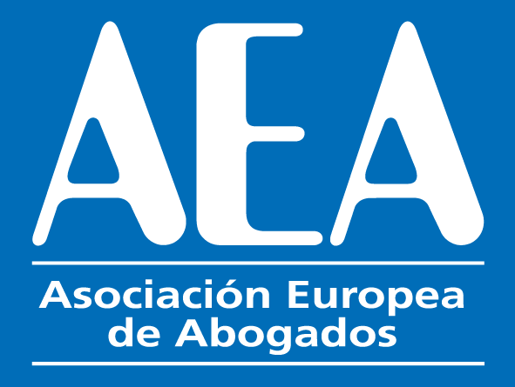

XVI INTERNATIONAL CONGRESS

Barcelona

EXCURSION SATURDAY 28THMay 2022
Excursion tour of Barcelona

9.00. Departure by bus from the Hotel Hesperia-Hyatt (Hospitalet)

1. 9.15. Plaça de Catanlunya (Catalonia Square)
2. 9.20. Les Rambles de Catalunya (Catalonia Boulevard)
3. 10.00.Catedral de la Santa Creu i Santa Eulalia de Barcelona (Cathedral of Barcelona) visit of the interior.
4. 10.30. Barri Gòtic. Ciutat Vella. (The Gothic Quarter and old Town)
5. 11.15. Plaça Sant Jaume. Palau de la Generalitat Catalana. (Square of Saint James. Palace of the Catalan Government)
6. 11.45 Palau de la Música Catalana (Palace of Catalan Music). Exterior visit.
7. 12.15. La Pedrera. (The stone quarry) and Casa Batlló, Modernist private residences by Gaudi. External visit.
8. 13.30. Lunch in the traditional Catalan Restaurant “7 Portes”
9. 15.30. Sagrada Familia (Basilica of the Holy Family). Internal visit.
10. 17.15. Return to the Hotel.

The cost of the tour is 160 euros. This includes the lunch and the tickets to visit Sagrada Familia (Basilica of the Holy Family) and the Cathedral of Barcelona.

The form below has to be sent to europea1@aeuropea.com enclosing copy of the payment.
You can pay (160 Euros) with a bank transfer to the account below or by credit card in the following link https://www.aeuropea.com/tpv/

NAME OF BENEFICIARY: ASOCIACION EUROPEA DE ABOGADOS
BANK NAME AND ADDRESS: : C/ Gral. O'Donnell, 11, 03003 Alacant, Alicante.
IBAN CODE: ES69 0182 0101 76 0201534148
BANK BIC CODEBBVAESMMXXX
*****************************************************************************

Surname: __________________________________ First Name: _____________________________
Country: ________________________
E-mail: _________________________________________________
Phone:__________________________________________________

Number of people

-------------------------------------------------------------------------------------------------------

