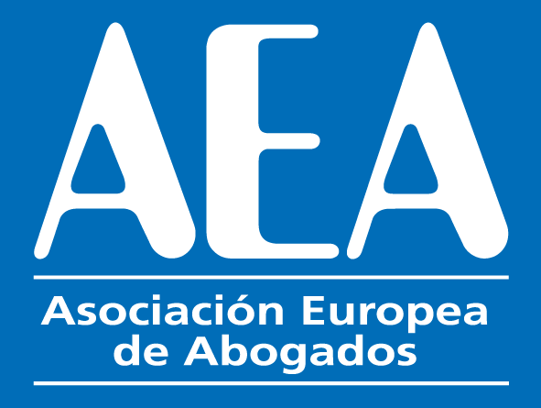

XVI INTERNATIONAL CONGRESS

Barcelona

26th and 27th May 2022

HOTEL HESPERIA HYATT BARCELONA
Gran Via,144 / 08907 L´Hospitalet de Llobregat (Barcelona) Spain
T: +34 93 413 50 45

"How to make your firm grow"

Thursday 26th May 2022

19.30 Dinner in Hotel Hesperia Hyatt Barcelona

Friday 27th May 2022

09.00. Opening of the congress in the hotel Hesperia Hyatt Barcelona

09.15. Introduction of the law firms taking part in the congress. Each law firm will be given three minutes for the introduction.

13.30. Buffet lunch in the Hotel Hesperia Hyatt Barcelona

15:15 PETER PANG (CHINA) How to keep good talent in a law firm.

15:30 JASIM DARWISH. (SAUDI ARABIA) International debt recovery as a source of cooperation between AEA offices.
15. 45 SHAILENDR RAMSAGUR (MAURITIUS). Challenges and need for reinvention of Law Firms in Africa?
16.00 SAMEER RASTOGI (INDIA) Start-Up investment transactions, upcoming practice area for law firms.

16.15 ROBERTO NICOLINI (ITALY) Social media and platforms to get new clients.

16.30 DANIEL ORDAS (SWITZERLAND) The value of the legal profession and its international links in times of conflict
16.45 MARIE-CLAIRE FREUNDLICH (FRANCE) The challenge between Versatility and/or Increasing Specific Qualifications.
17.00 PEDRO BELTRAN (SPAIN) How to make your firm grow through the AEA Network.

17.30. End of the congress

19.30 Gala dinner in Hotel Hesperia Hyatt Barcelona

Saturday 28 th May 2022

Excursion tour of Barcelona.

9.00. Departure by bus from the Hotel Hesperia-Hyatt (Hospitalet)

1. 9.15. Plaça de Catalunya (Catalonia Square)
2. 9.20. Les Rambles de Catalunya (Catalonia Boulevard)
3. 10.00. Cathedral de la Santa Creu i Santa Eulalia de Barcelona (Cathedral of Barcelona). External visit
4. 10.30. Barri Gòtic. Ciutat Vella. (The Gothic Quarter and old Town)
5. 11.15. Plaça Sant Jaume. Palau de la Generalitat Catalana. (Square of Saint James. Palace of the Catalan Government)
6. 11.45 Palau de la Música Catalana (Palace of Catalan Music). Exterior visit.
7. 12.15. La Pedrera. (The stone quarry) and Casa Batlló, Modernist private residences by Gaudi. External visit.
8. 13.30. Lunch in the traditional Catalan Restaurant “7 Portes”
9. 15.30. Sagrada Familia (Basilica of the Holy Family). Internal visit.
10. 17.15. Return to the Hotel.

