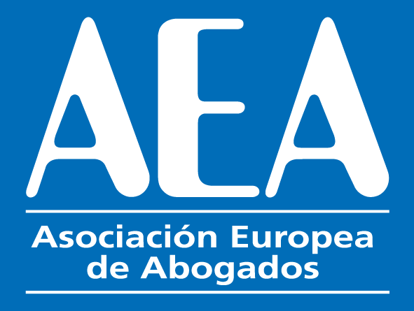
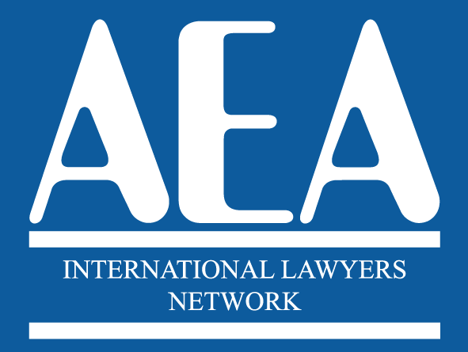

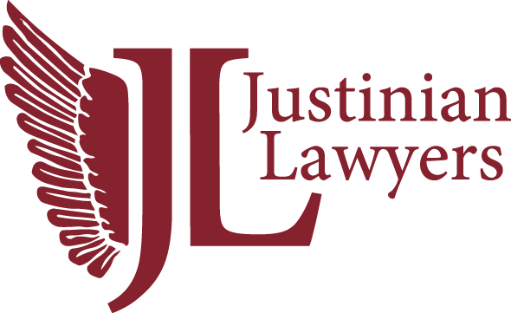

XVII INTERNATIONAL CONGRESS

VIENNA

EXCURSION SATURDAY 27THMay 2023
Excursion tour of Vienna

06.30. Optional for Early Birds. Guided Morning Run with Local Lawyer.
- 9.00. Departure by bus from the Hotel Event Pyramide
- 9.30. Visit of the Imperial Palace of Schönbrunn
- 11.00. Tour of Vienna
- 13.30. Lunch in the traditional restaurant Stöckl im Park
- 15.30. Return to the Hotel.

The cost of the tour is 160 euros. This includes the lunch and the tickets to visit Schönbrunn Palace.

The form below has to be sent to europea1@aeuropea.com enclosing copy of the payment.
*****************************************************************************

Name: _____________________________
Country: ________________________
E-mail: _________________________________________________

Number of people

-------------------------------------------------------------------------------------------------------
PAYMENT CAN BE MADE BY CREDIT CARD IN

https://www.aeuropea.com/payment-by-credit-card/

OR BY BANK TRANSFER TO THE FOLLOWING ACCOUNT

NAME OF BENEFICIARY: ASSOCIATION OF EUROPEAN LAWYERS

BANK NAME AND ADDRESS: C/ Gral. O'Donnell, 11, 03003 Alicante (Spain)

IBAN CODE: ES ES54 0182 0101 71 0201571426

BANK BIC CODE BBVAESMMCCC

