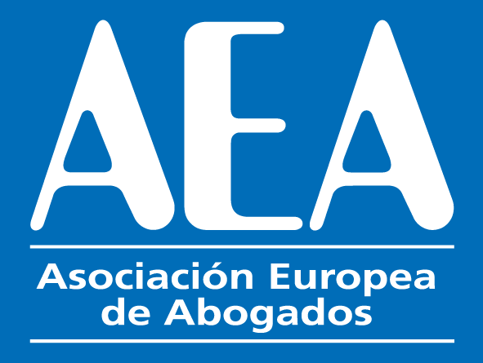

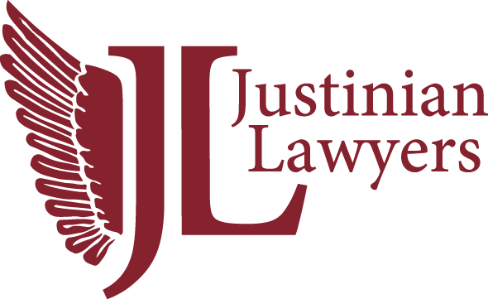

XVII INTERNATIONAL CONGRESS
Vienna
25th and 26th May 2023
BOOKING FORM.
EVENTHOTEL PYRAMIDE
Parkallee 2, 2334 Vienna- Vösendorf

"Marketing for law firms"

Please send this form to europea1@aeuropea.com

*****************************************************************************

Name: _____________________________
Country: ________________________
E-mail: _________________________________________________

MEETING PACKAGE

25th May and 26th May – Meeting Participation Fee 260 euros per person

Number of people

Includes the dinner of 25th May, the lunch of 26th May, the dinner of 26th May, coffee-break the 26th May and the proportional amount for the booking of the auditorium and audiovisuals.

GUESTS (only for guests that are not lawyers an that are not attending the congress)

DINNER ON THE 25TH MAY. Supplement for guests that don´t take the meeting package and attend the dinner on the 25th May:
50 € per person – Number of people:
Name of the guest:

DINNER ON THE 26TH MAY. Supplement for guests that don´t take the meeting package and attend the dinner on the 26th May
50 € per person – Number of people:
Name of the guest:

EXCURSION TOUR

EXCURSION Saturday 27TH MAY.
160 € per person – Number of people:

PAYMENT CAN BE MADE BY CREDIT CARD IN

https://www.justinianlawyers.com/product/payment/

