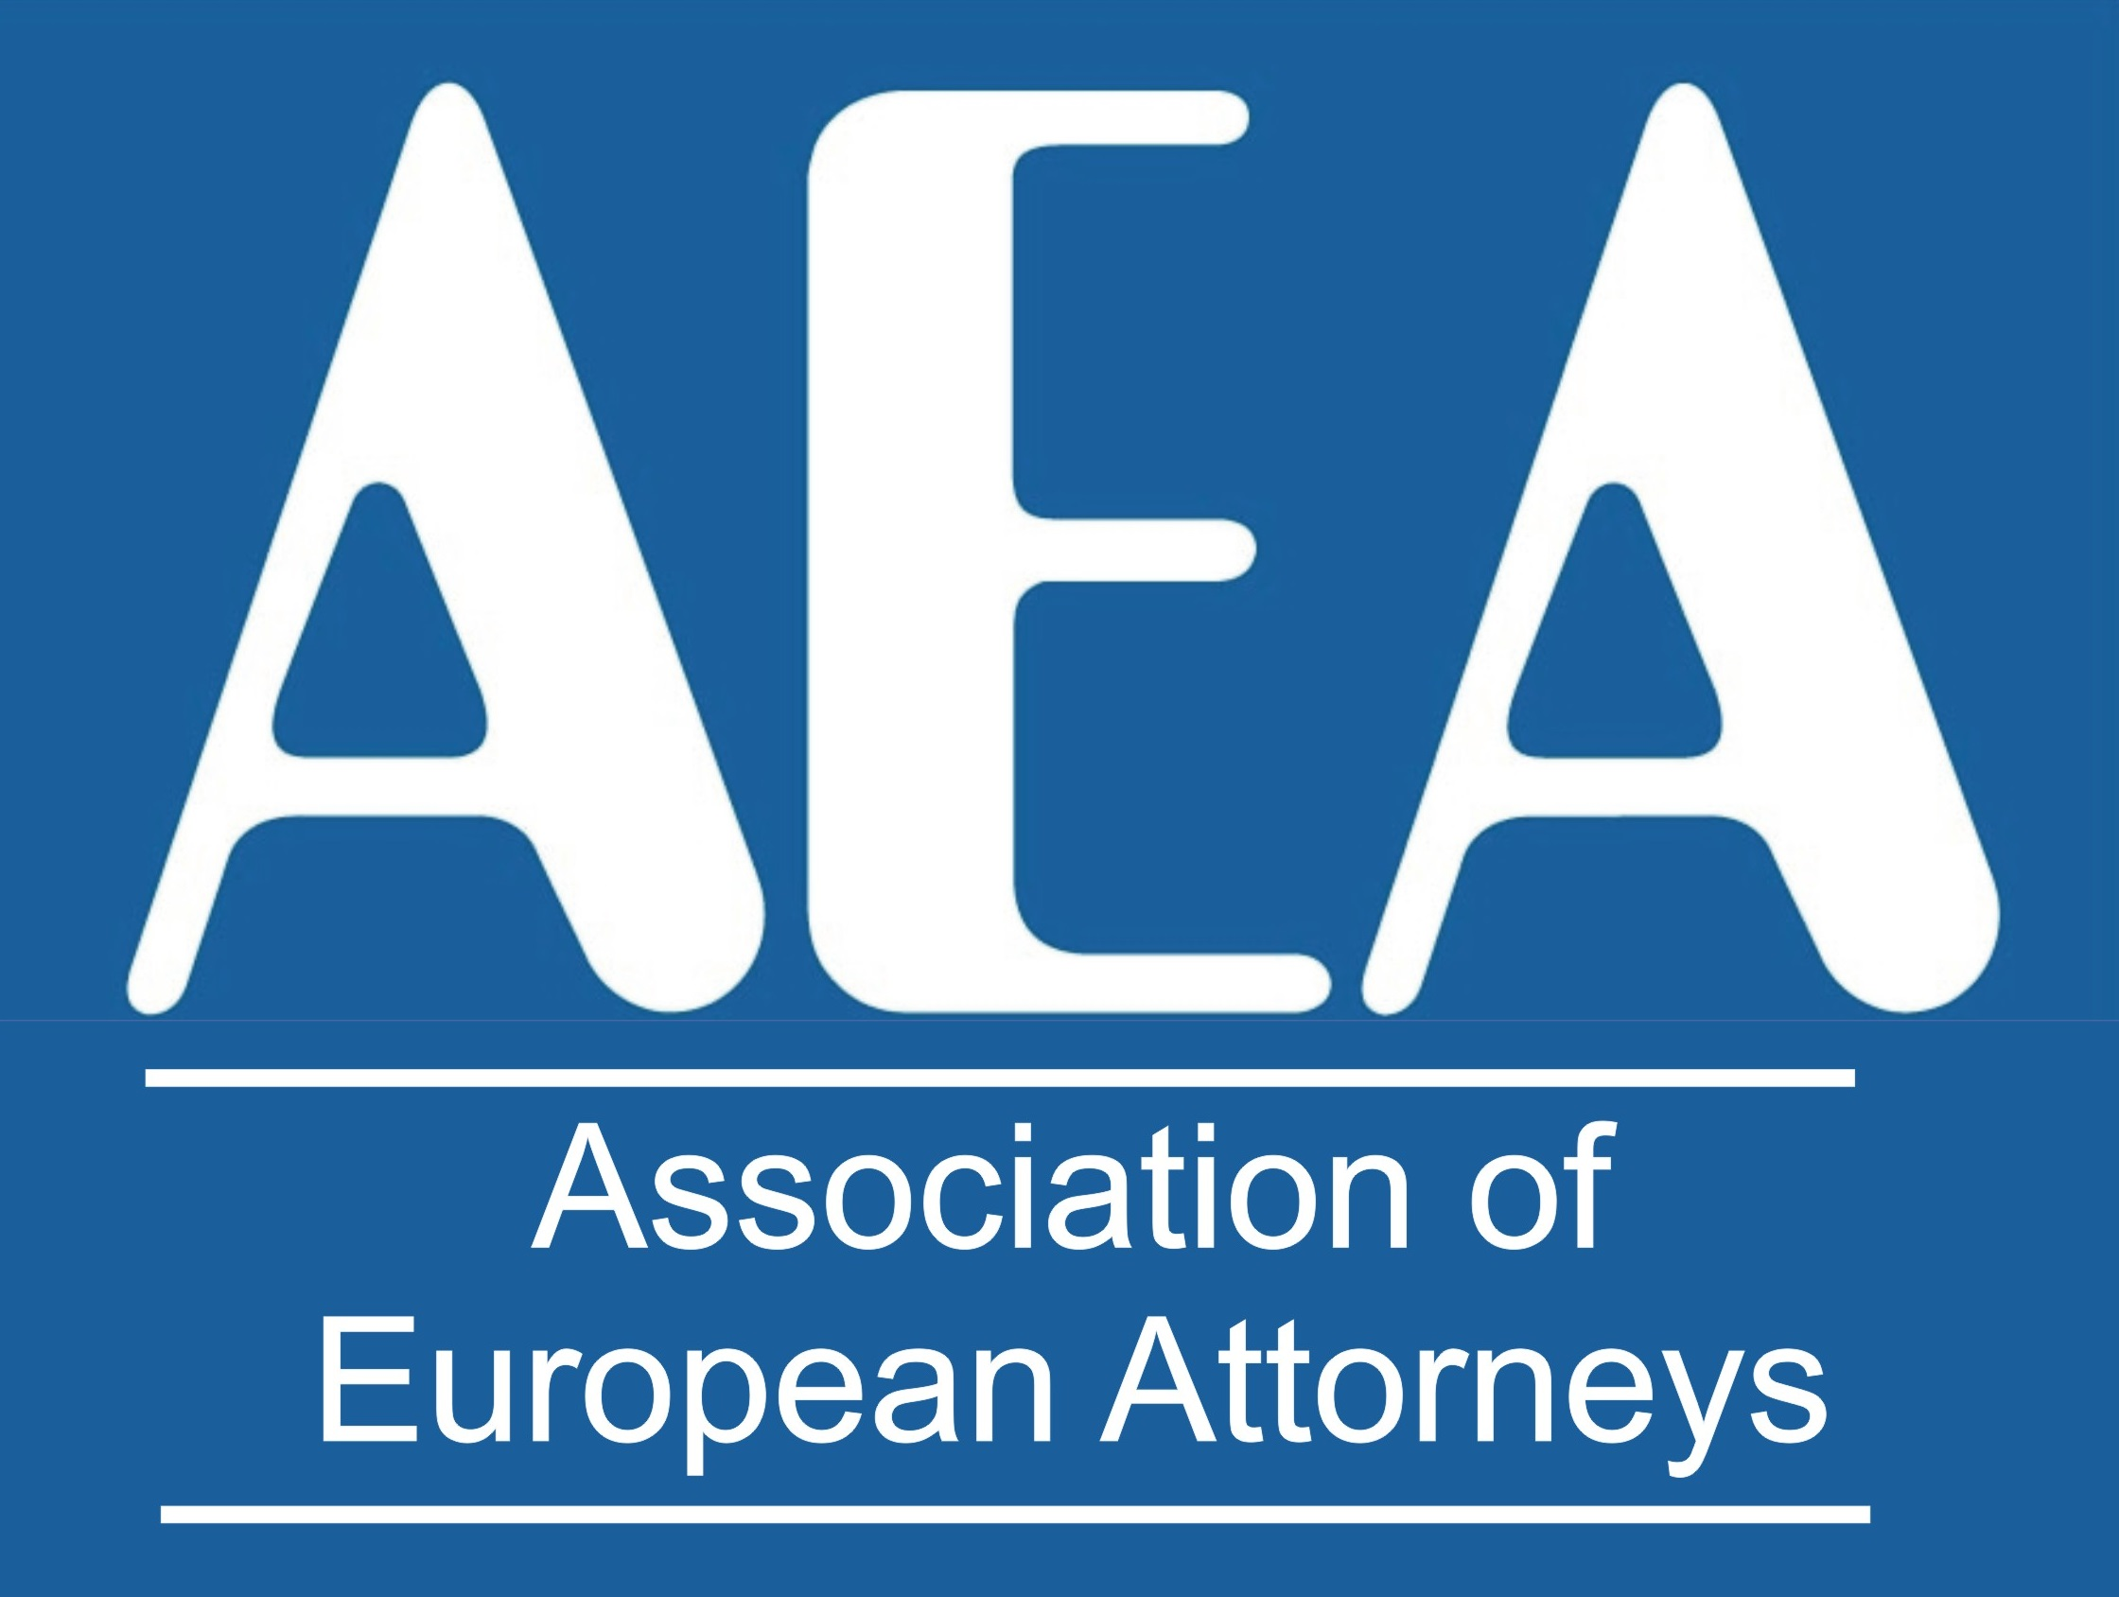  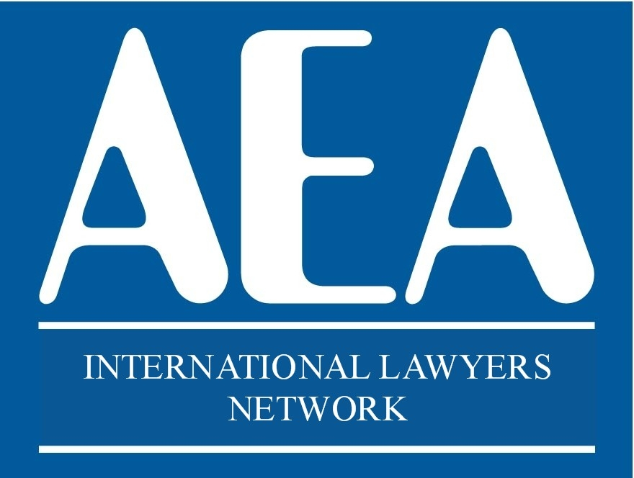

***XIX INTERNATIONAL CONGRESS***

***Madrid***

***22nd and 23rd May 2025***

***HILTON MADRID AIRPORT***

***Av. De la Hispanidad 2-4. Madrid, 28042. Spain.***

***"ANNUAL CONGRESS"***

**Please send this form** to **europea1@aeuropea.com**

**\*\*\*\*\*\*\*\*\*\*\*\*\*\*\*\*\*\*\*\*\*\*\*\*\*\*\*\*\*\*\*\*\*\*\*\*\*\*\*\*\*\*\*\*\*\*\*\*\*\*\*\*\*\*\*\*\*\*\*\*\*\*\*\*\*\*\*\*\*\*\*\*\*\*\*\*\***

 Name: _____________________________

Country: ________________________

E-mail: _________________________________________________

**MEETING PACKAGE**

22nd May and 23rd May 2025– Meeting Participation Fee 390 euros per person



Number of people

Includes the dinner of 22nd May, the lunch of 23rd May, the dinner of 23rd May, coffee-break the 23rd May and the proportional amount for the booking of the auditorium and audiovisuals.

# **GUESTS (only for guests that are not lawyers an that are not attending the congress)**

DINNER ON THE 22ND MAY. Supplement for guests that don´t take the meeting package and attend the dinner on the 22nd May:

**75 €** per person – Number of people:

## Name of the guest:

DINNER ON THE 23TH MAY. Supplement for guests that don´t take the meeting package and attend the dinner on the 23rd May

**75 €** per person – Number of people

## Name of the guest:

**EXCURSION TOUR**

EXCURSION Saturday 24th May.

**180 €** per person – Number of people:

**PAYMENT CAN BE MADE BY CREDIT CARD IN**

<https://www.aeuropea.com/product/payment/>