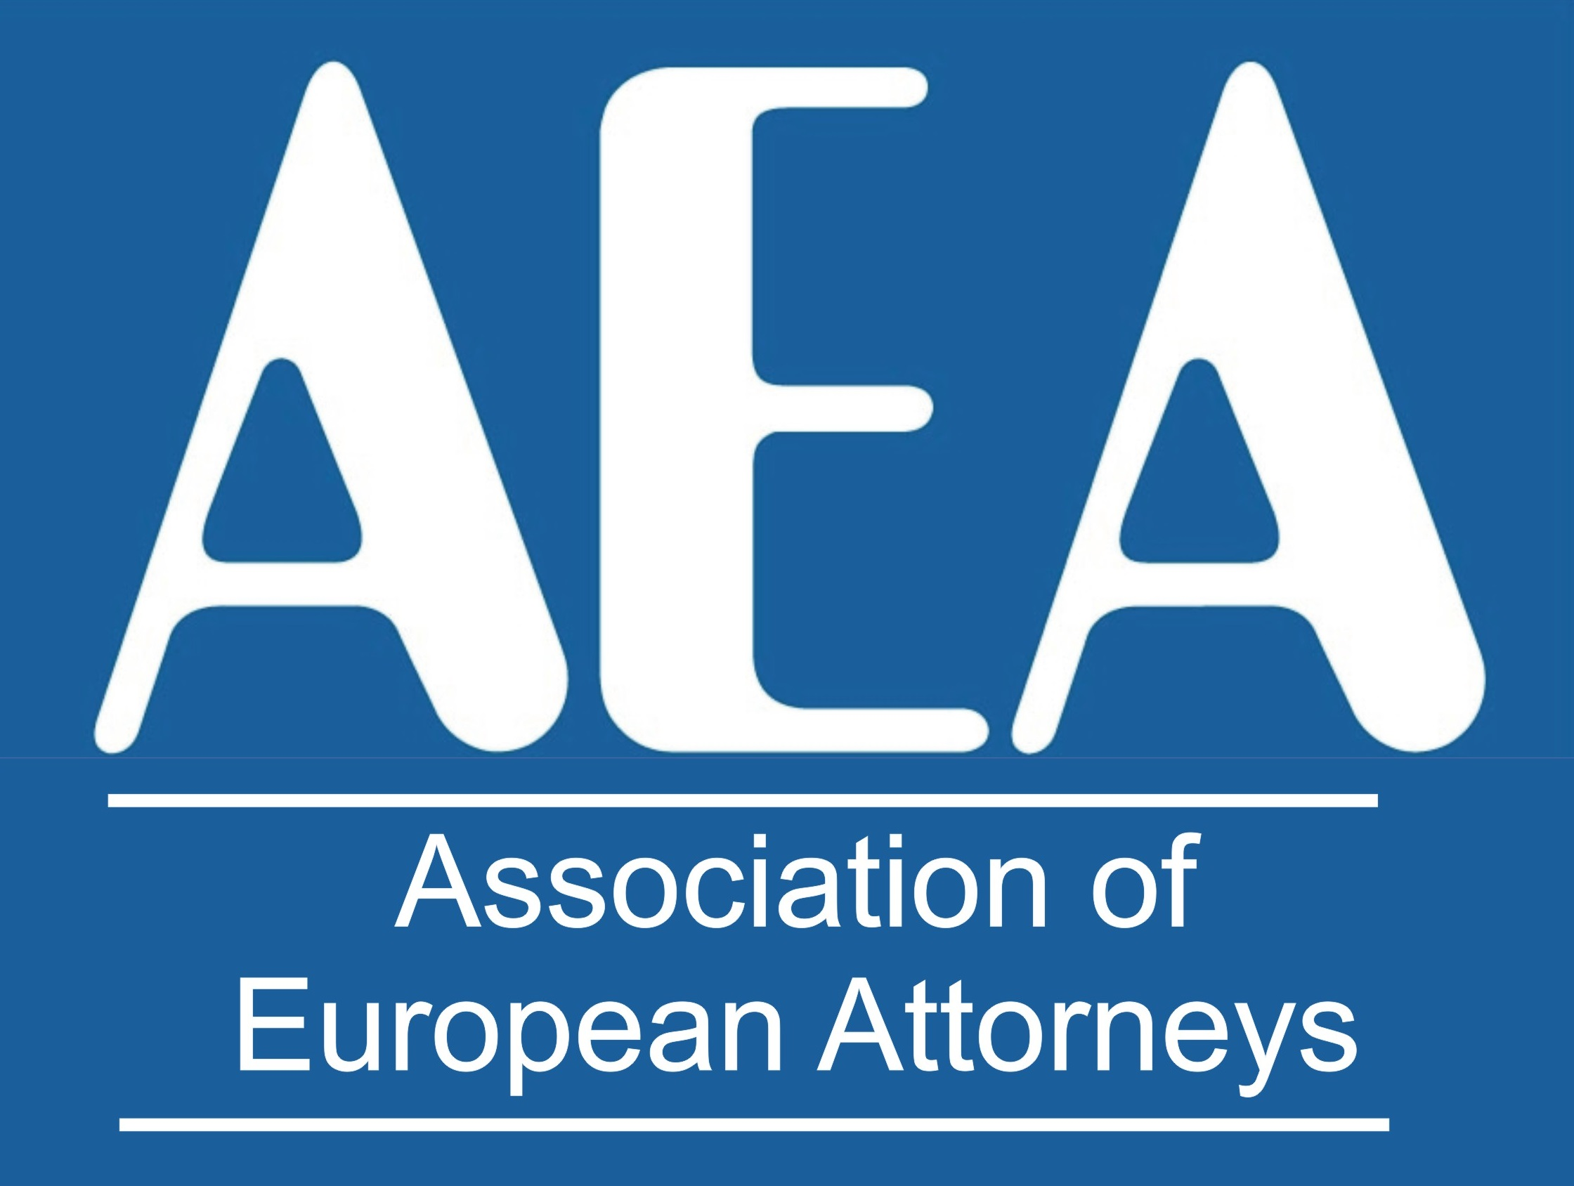 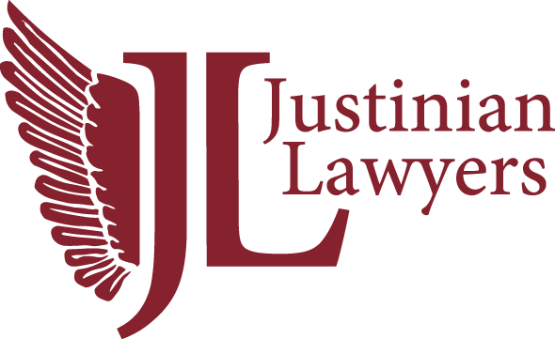 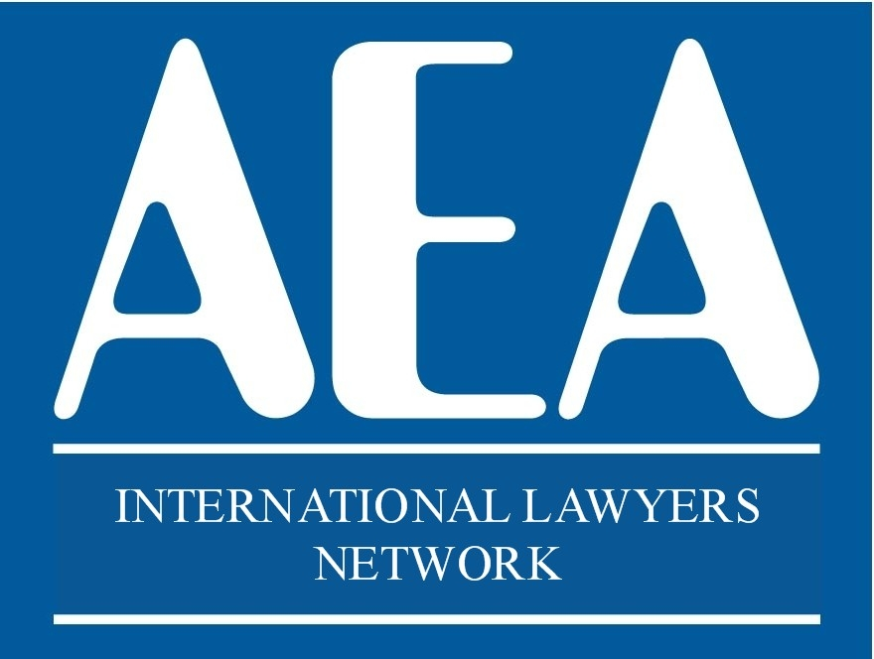

***22TH ANNIVERSARY CONGRESS***

***PARIS***

***28th and 29th May 2026***

***HOTEL RESERVATION***

***H4 HOTEL WYNDHAM***

***Paris Pleyel Resort***

***149 Bd Anatole France, 93200 Paris, Saint-Denis.***

***22TH ANNIVERSARY CONGRESS***

**The congress has a limited number of available spots. Registration will close once all spots have been filled.**

Please note that we can only process your registration and reserve your place **once payment has been completed.**

Amounts paid will be reimbursed in the event of non-attendance. Please note that **the deadline for refund requests is Wednesday, May 13, 2026, at 8:00 PM** (Berlin time).

Please send this completed form to: europea1@aeuropea.com

Name: ________________________________________________________

Country: ______________________________________________________

E-mail: _______________________________________________________

**MEETING PACKAGE**

28th & 29th May 2026

**Participation Fee:** €390 per person

Number of people

Includes: Dinner on 28th May, Lunch on 29th May, Dinner on 29th May, Coffee break on 29th May and proportional share of auditorium and audiovisual equipment costs.

# **GUESTS OPTIONS (For guests not attending the congress sessions)**

DINNER – 28th May. Supplement for guests not taking the meeting package:

**90 €** per person – Number of guests:

## Guest name(s):

DINNER 29th May. Supplement for guests not taking the meeting package:

**90 €** per person – Number of guests:

## Guest name(s):

**EXCURSION TOUR**

EXCURSION – Saturday, 30th May.

**190 €** per person – Number of participants:

**PAYMENT CAN BE MADE BY CREDIT CARD IN**

https://www.aeuropea.com/product/payment/