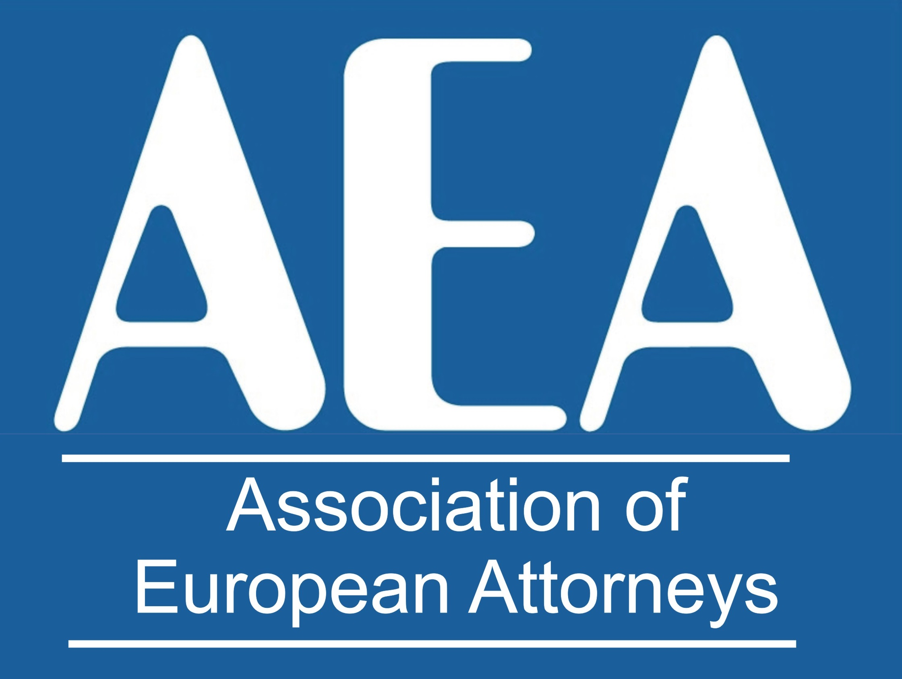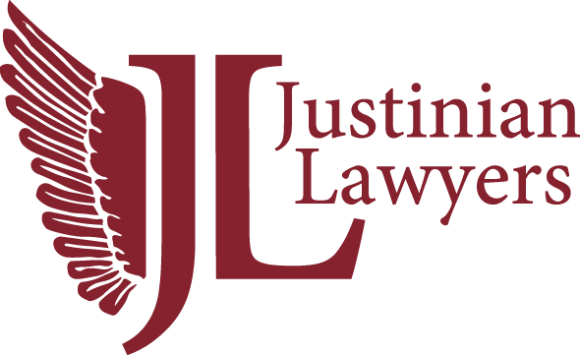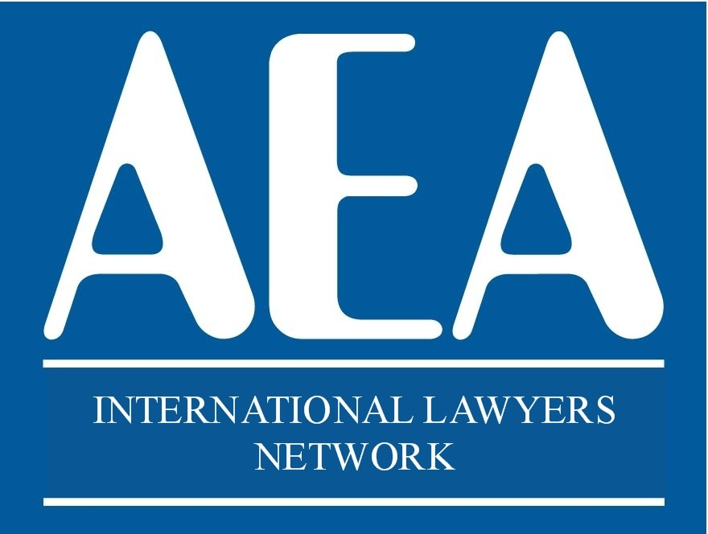

22TH ANNIVERSARY CONGRESS

PARIS

28th and 29th May 2026

HOTEL RESERVATION

H4 HOTEL WYNDHAM

Paris Pleyel Resort

149 Bd Anatole France, 93200 Paris, Saint-Denis.

22TH ANNIVERSARY CONGRESS

The congress has a limited number of available spots. Registration will close once all spots have been filled.
Please note that we can only process your registration and reserve your place once payment has been completed.
Amounts paid will be reimbursed in the event of non-attendance. Please note that the deadline for refund requests is Wednesday, May 13, 2026, at 8:00 PM (Berlin time).
Please send this completed form to: europea1@aeuropea.com

Name: ________________________________________________________
Country: ______________________________________________________
E-mail: _______________________________________________________

MEETING PACKAGE

28th & 29th May 2026
Participation Fee: €390 per person

Number of people

Includes: Dinner on 28th May, Lunch on 29th May, Dinner on 29th May, Coffee break on 29th May and proportional share of auditorium and audiovisual equipment costs.

GUESTS OPTIONS (For guests not attending the congress sessions)

DINNER – 28th May. Supplement for guests not taking the meeting package:
90 € per person – Number of guests:

Guest name(s):

DINNER 29th May. Supplement for guests not taking the meeting package:
90 € per person – Number of guests:

Guest name(s):

EXCURSION TOUR

EXCURSION – Saturday, 30th May.
190 € per person – Number of participants:

PAYMENT CAN BE MADE BY CREDIT CARD IN
https://www.aeuropea.com/product/payment/

